Our Baseline:
Create a KWL chart that shows what you a;ready know about Music Education please ensure your work is ground in a particular theory or School of Thought, What you want to know and leave the third section blank.

Our Reading:
Please read Bennett Reimer's A Philosophy of Music Education chapter two and answer the following questions:

How does an experience based model help us create pathways for music creation?

Speak to the alternative views in this chapter:

Compare and contrast your views prior to reading this chapter with your views now in this venn diagram

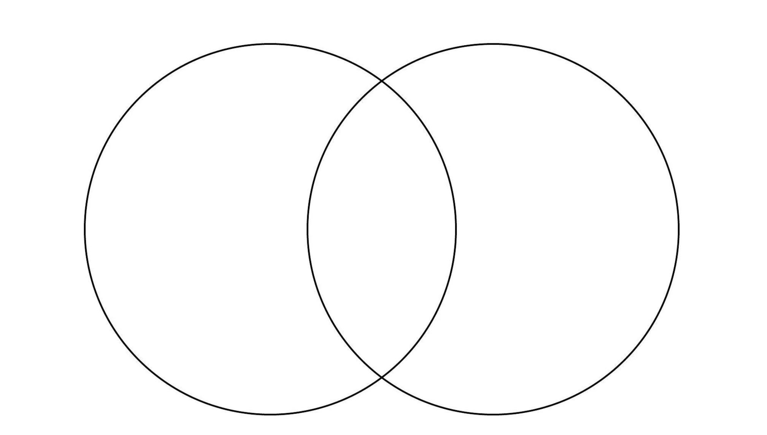
Finalize your thoughts:

Please fill out your L ( learned section of your KWL chart )

