Course Syllabus: Digital Music

Course Description:

The Roy H Mann Digital Music and Composition course is modeled after the Project Based Learning (PBL) Model. Offered in both the fall and spring semesters as a Student Enrichment Model (SEM) course and as an 8th grade programmed course. Students during participation in this course will explore various forms of digital music creation and will explore other digital multimedia. This course focuses on the idea that all students have the capacity and ability to be musical. Students will have the opportunity for choice in their work throughout the course of the semester. Our class is a computer based course and students will have the opportunity for some traditional music making with instruments; the majority of our classes focus will be on the creation of digital music in programs like Soundtrap and Ableton Live.

Grading Policy:

Digital Music is offered in a Variety of Course Offerings, For SEM Classes ONLY this class is offered as a P/F ( Pass / Fail ) Course. Students will be expected to meet all expectations and to submit all assignments and projects during the appropriate due date. Late work will not be accepted without a letter of explanation from a parent or guardian.

8th Grade Minor: This section of Digital Music is Graded on a 0-100 scale.

25% - Daily Participation

Participation is a daily grade and may be subtracted for the following reasons
- Students consistently Arrive Late to Class.
- Students do not complete daily assignments for classwork in a timely manner.
- Students are consistently off task.

70% - Projects
5% - Homework

Homework Policy:

Any in class work that is marked as incomplete during the class period it is assigned will become homework due the following class period.

Major Projects:

My Favorite Musician Website:

Students will create a Website based around their favorite musical Artist or Band. This project will comprise a variety of Design, Musical Composition, Research, and Exploration.

Artist Bio | MFS Page | Artist Research | Cover or Remix of a Song | Design
Students will write an artist bio to introduce their favorite musical Artist(S) | Students will create a page to show their audience their favorite songs and give explanation and reasoning | Students will be expected to complete research about their favorite musician and make it evident. | Students will complete a cover or a remix of a song by their musical artist of choice. | Websites design must be clear, cohesive and it will be evident that the student has put thought and time into the design and layout of their website.

Soundtrack for a Short Film

This Project will help students become acquainted with the different Digital Audio Workstations we will be using throughout the course of the semester. Students will create a soundtrack to a short scene of their choice (students will have the opportunity to select from three pre chosen scenes). Students must follow the included rubric and meet all submission requirements, all work must be submitted by the due date.

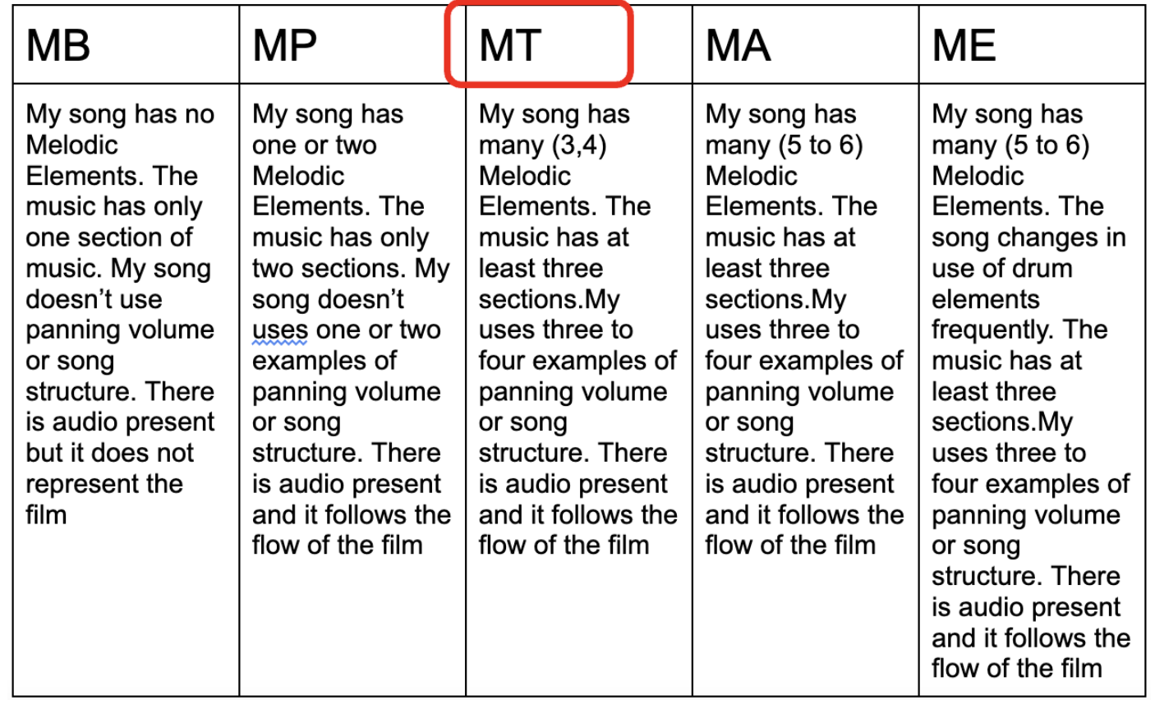

Collaborative Recording Project

Final Album Or EP:

Students will over the course of the semester or year accumulate several songs and projects. Over the course of this project, students will complete the process of recording, mixing, mastering and distributing their creation. Students in SEM will create a four track EP.

Course Calendar:

Month | 8th Grade Minor | SEM
September | Introduction to Digital Music | Introduction to Digital Music
October | First Project: Websites | First Project: Websites
November | First Project: Websites | Second Project: Movie Soundtracks
December | Collaborative Songs | Collaborative Songs
January | Form, Song Structure, Instrumentation | Third Project: EP
February | Second Project: Film Scoring | Introduction to Digital Music
March | Second Project: Film Scoring | First Project: Websites
April | Third Project: Final Album | Second Project: Movie Soundtracks
May | Third Project: Final Album | Collaborative Songs
June | Third Project: Final Album | Third Project: EP

